Compliance with European Pressure Equipment Directive (PED)

At SuperKlean Washdown Products, we are committed to upholding the highest standards of safety and quality in our products. We are proud to announce that our products adhere to the European Pressure Equipment Directive (PED) EN 2014/68/EU. This directive pertains to stationary pressure equipment with a maximum allowable pressure exceeding 0.5 bar. SuperKlean products that meet this standard include the DURAMIX 8000 Steam and Cold Water Hose Station Series and the 3600 Series of Hot and Cold Hose Stations.
The PED aims to guarantee the free movement of products within its scope across the European Union while ensuring a high level of safety for users. Our adherence to this directive signifies our dedication to ensuring that our products not only meet but exceed the stringent safety standards set by the European Union.
Furthermore, as a testament to our commitment to European standards, we ensure that our hose station pressure equipment and assemblies comply with the requirements of the PED. This ensures the safety and reliability of SuperKlean products when they are sold in Europe.
By aligning with the PED and other European standards, SuperKlean reaffirms its dedication to delivering products that are safe, reliable, and of the highest quality to our customers in Europe and around the world.
For more information on SuperKlean, please contact Bob Rudy, VP of International Sales and Marketing, at 1-800-769-9173 or direct at 1-949-533-2300, or by email at sales@superklean.com.
For more information on the Pressure Equipment Directive, please refer to the official European Commission's Pressure Equipment Directive page.

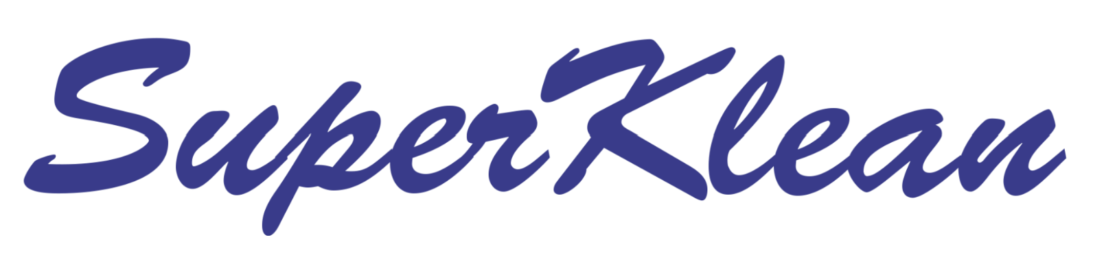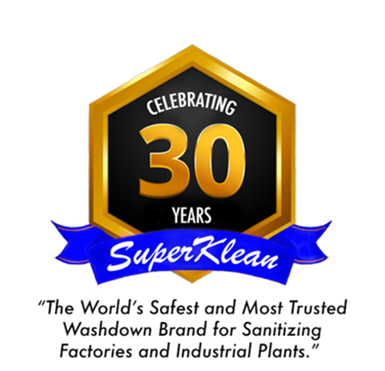
SuperKlean Address:
1 Edwards Court, #101,
Burlingame, California 94010 USA

